Contents

GitHub Repository 1

Clone Repo from GitHub 1

Update Remote Repo URL (in existing Cloned Repo) 3

Verify Remote Repo URL 3

Generate Personal Access Token 3

Connect to GitHub 3

Generating Token 4

Copy the token 7

Authorize the Token 8

# MY GitHub Repository

1. The “enterprise GitHub can be accessed through https URL
2. Existing Bitbucket repositories which have been migrated to GitHub has been set to read only mode.
3. The new repository clone URL is <https://github.com/nagu3693/myrepo.git>
4. To access the repository through Git Bash, Tortoise GIT, Source Tree etc. you will need to generate the **Personal Access Token**
5. The instructions can be found in this document.
6. The instructions in this document for any repository
7. In case you face SSL certificate issue, execute below command in GIT Bash

***Command****: git config --global http.sslVerify false*

# Clone MY Repo from GitHub

1. If you want to setup a new workspace using GitHub, clone the repository using below command

**Command**: git clone <https://github.com/nagu3693/myrepo.git>

**Example for my repo**: git clone <https://github.com/nagu3693/myrepo.git>



1. This will prompt you to authenticate to GitHub. To authenticate to GitHub, use your GitHub ID and use **Personal Access Token and not the password** in the password field. (The procedure for generating Personal Access token is described in this document.)
2. In case you are using later versions of GIT which comes with Git Credential Manager, it will give option to either authenticate using browser or through Personal Access Token. You may choose either but the Personal Access Token would be preferred. Refer following screenshot;

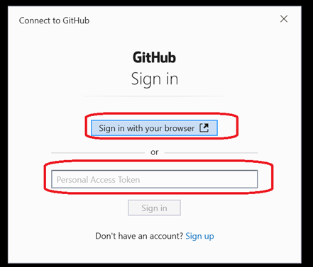

# Update Remote Repo URL (in existing Cloned Repo)

1. If you want to continue using existing workspace, update the remote URL to GitHub.

**Command**: git remote set-url origin <https://github.com/nagu3693/myrepo.git>

**Example For Hybris:** git remote set-url origin <https://github.com/nagu3693/myrepo.git>

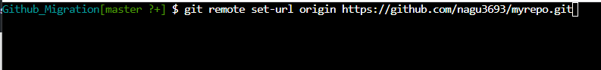

1. This will prompt you to authenticate to GitHub during Git operations like push, pull etc. To authenticate to GitHub, use your GitHub ID and use **Personal Access Token and not personal password** in the password field. (The procedure for generating Personal Access token is described in this document.)

# 

# Verify Remote Repo URL

1. Use the following commands to verify the remote URL configured in Git Bash

Command: git remote -v



1. It should be set to the new GitHub URL (and not to the earlier BitBucket URL)

# Generate Personal Access Token

## Connect to GitHub

1. Connect to my Personal repo)
2. Login to [GitHub](https://github.com/) using your username and your Github password for SSO sign on through the browser.

## Generating Token

1. Go to Settings under your profile (top right of the GitHub Home page)

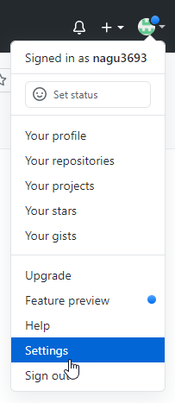

1. Go to Developer Settings in the Settings page (scroll down in the settings page to see the option)

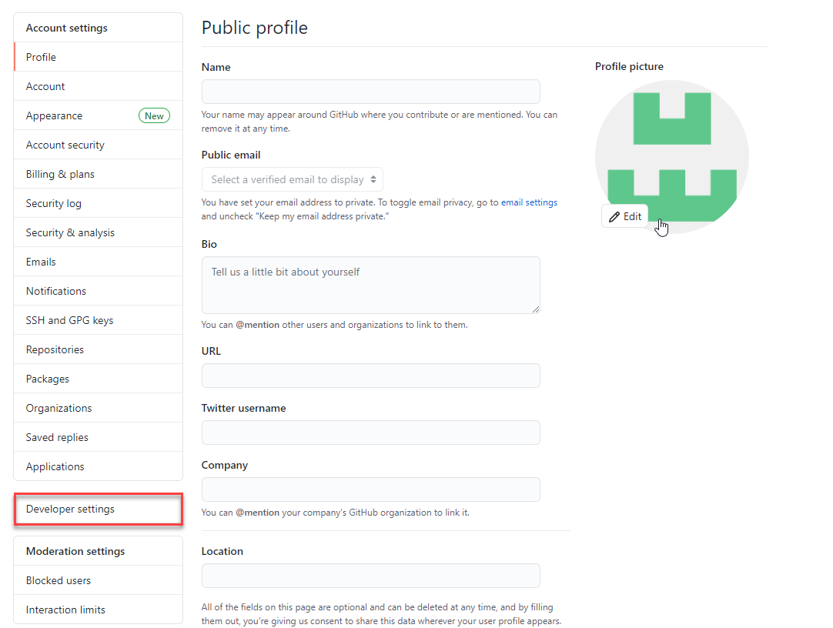

1. Click on “Personal access tokens” and then “Generate new token”

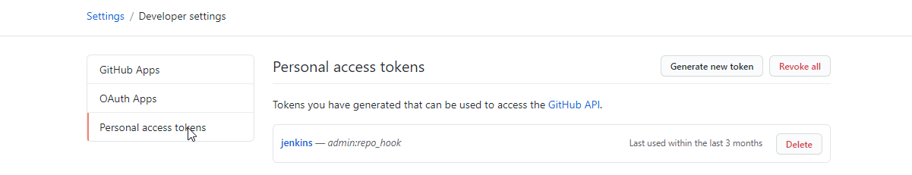

1. In the “New personal access token” page,
2. Give a suitable name for the Token.
3. Select the following privileges for the token and click “Generate token” (Refer below screenshot);

Note: Do not select the “delete” privileges.

1. repo
2. workflow
3. write:packages
4. admin:org
5. admin:public_key
6. admin:repo_hook
7. admin:org_hook
8. user
9. write:discussion
10. admin:gpg_key

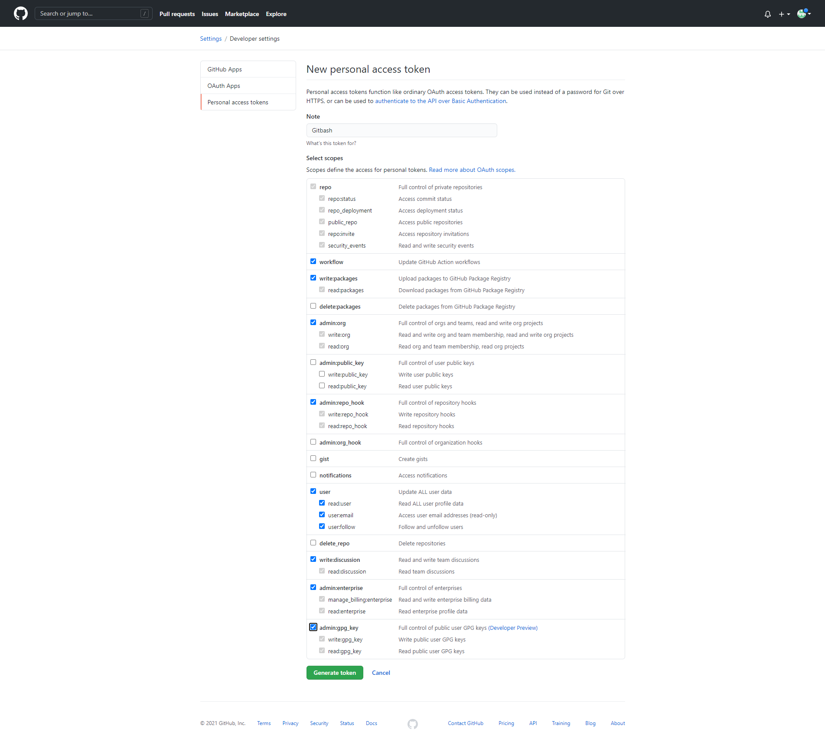

1. Copy and Authorize the Token

## Copy the token

**VERY IMPORTANT**: Copy the token generated and store in Text pad or a password protected file. **Once you save it in Github UI you will not see the token**. The generated **token will be your password to access GitHub** using Git Bash, Tortoise GIT, Source Tree etc.

**Important Github Links:**

**PERSONAL TOKEN GENERATION FOR ACCESSING THE GITHUB REPO**

[https://docs.github.com/en/github/authenticating-to-github/authorizing-a-personal-access-token-for-use-with-saml-single-sign-on](https://protect-us.mimecast.com/s/q1FLCR684Nfl9w74Iot7cZ)

**(NOTE: SAVE THE PERSONAL ACCESS TOKEN AND WHEN YOU CLONE THE GITHUB REPO USING HTTPS GITHUB URL USE  YOUR GITHUB USERNAME AND WHEN IT PROMPTS FOR PASSWORD ENTER THE GENERATED PERSONAL ACCESS TOKEN)**

**CHANGE REMOTE ORIGIN:**

[https://docs.github.com/en/github/using-git/changing-a-remotes-url](https://protect-us.mimecast.com/s/eiAOCNk7ZJHxKYvki4LB6R)

**POINTING TO NEW GITHUB ORIGIN.**

git remote set-url origin <https://github.com/nagu3693/myrepo.git>

**VERIFYING THE URL IS CORRECTLY POINTE TO GITHUB**

**#(NOTE:IF YOU RUN THIS SHOULD SHOW REMOTE POINITNG TO NEW GITHUB URLS)**

$ git remote -v

> origin https://github.com/nagu3693/myrepo.git (fetch)

> origin  https://github.com/nagu3693/myrepo.git (push)

<https://guides.github.com/activities/hello-world/>